Design Plan for Street-Wear apparel Website

Arjun Vaswani

September 25th 2024

Course: Web Programming I

# 

# 

# Jun Street-Wear Apparel

Jun Street-Wear Apparel specializes in unique clothing designs inspired by the street-wear aesthetic. The brand's goal is to deliver stylish clothing that resonates with its audience.

# Purpose

Jun Street-Wear Apparel hopes to broaden horizons and reach new audiences all across the globe. An online platform featuring the designs online also allows people all across the globe to find designs that resonate with them, motivating them to go find those designs in-store another time. The website will inform potential customers about the locations, hours, pricing and motive behind the brand. The website is also stylistically designed to leave an impression on the user of what the brand is all about.

# Targeted Audience

The target audience of Jun Apparel is majoritarily teenagers and young adults seeking unique clothing items that stand out compared to other designs on the market. The website will be designed for easy use, prioritizing a straightforward, modern and sleek design. User’s technical abilities will not be tested. The site aims for simplicity, making it as easy as possible to see the designs the brand has to offer. This is the target demographic as teens and young adults are an age group that experiments with and values fashion much more than other groups. The street-wear inspired aesthetic also resonates more with younger audiences as it is a current trend in fashion.

# Planned Pages

## Home (Index)

The “Home” page will give users an introduction to the unique style the brand's clothing brings. It is stylistically designed to be straightforward as well as distinct. It provides users with the information they need to understand what the brand stands for at a base level. It also serves as the page designed to lead users to different sub-pages of the website.

## Shop

The “Shop" page currently allows users to view products and various notable details about them they might wish to know before purchasing them in person. In the future, this page will allow users to find designs they like, purchase them fully online, and have them delivered to their doorstep.

## Find a Store

The “Find a Store” page allows users to find the location closest to them, as well as details of that particular location, such as opening hours.

## About Us

The “About Us” page allows users to find out more about what the brand aims to achieve, allowing them to build a deeper connection and understanding of what the brand stands for. This page tells the story of the brand.

## Q&A

The “Q&A” page allows users' most commonly asked questions to be answered without the need of any wait. It provides an extensive list of questions along with their answers to answer any questions the user may have about the products sold.

# Logo



This logo was designed by Arjun Vaswani using the Hyperpix Productions Chrome Text Effect Vol. 8.

# Other Images

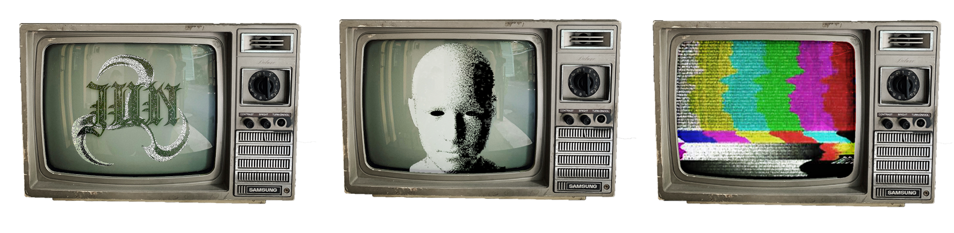

This image was designed by Arjun Vaswani using a retro tv from a royalty-free image found on pexels.com. It features some elements taken from retro-futuristic elements found on Adobe Stock.

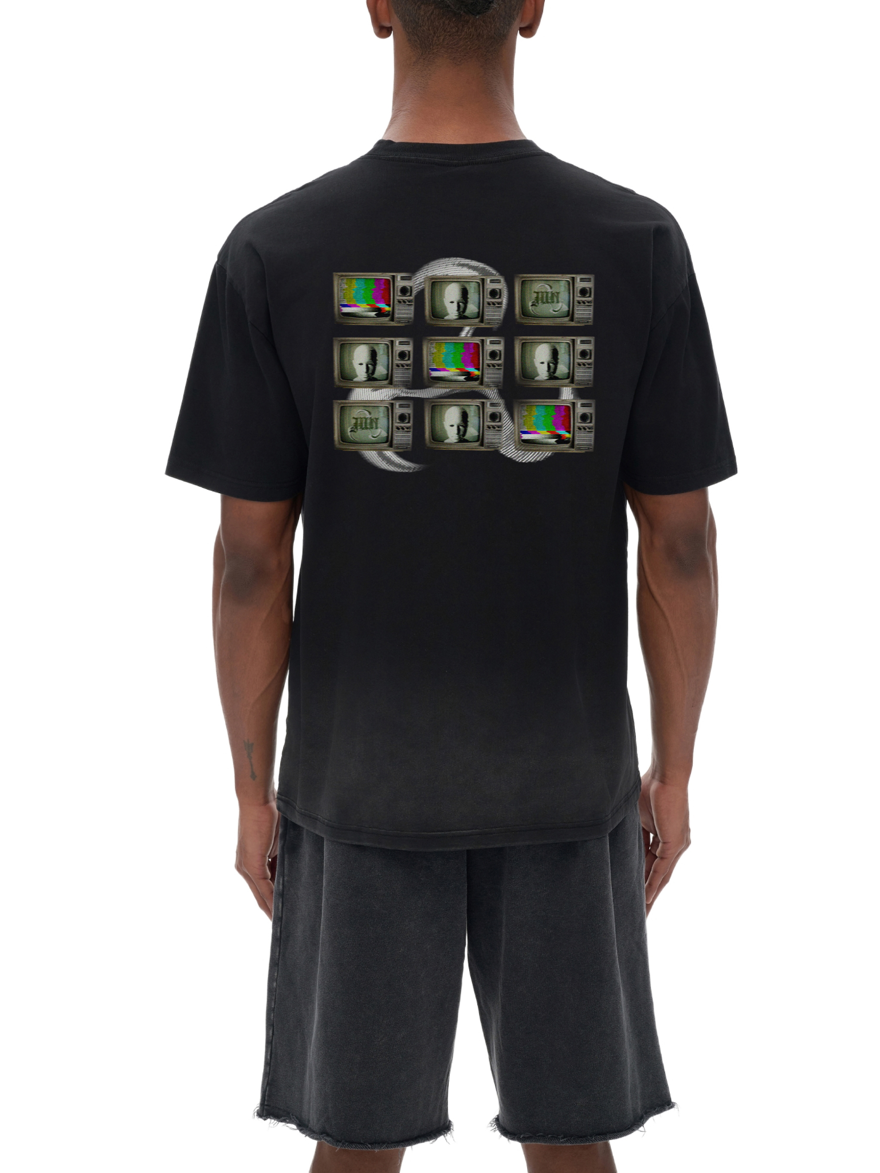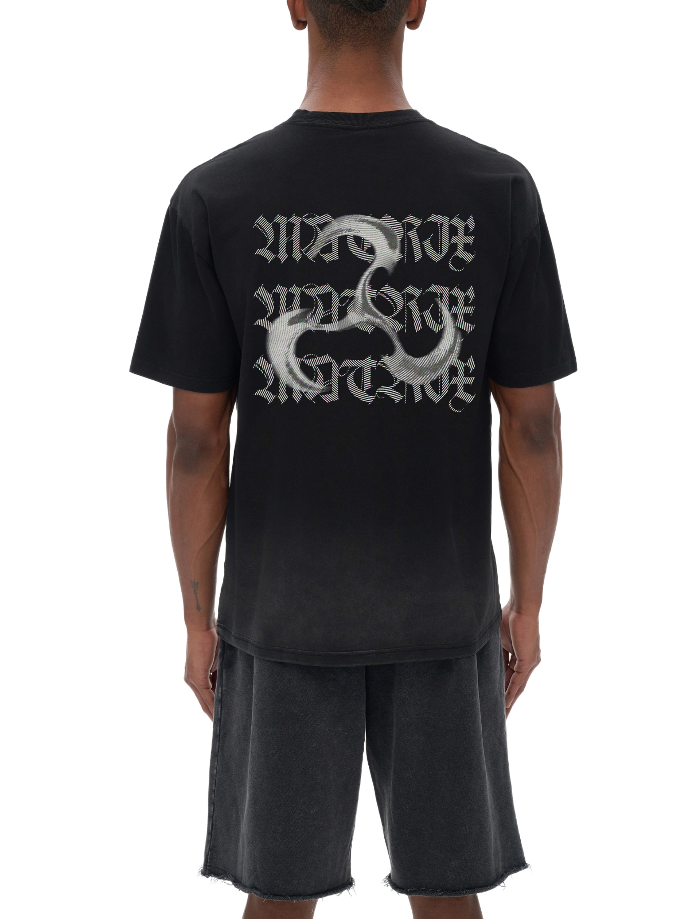

These were designed by Arjun Vaswani. The mockups used are free to download from tapstitch.com

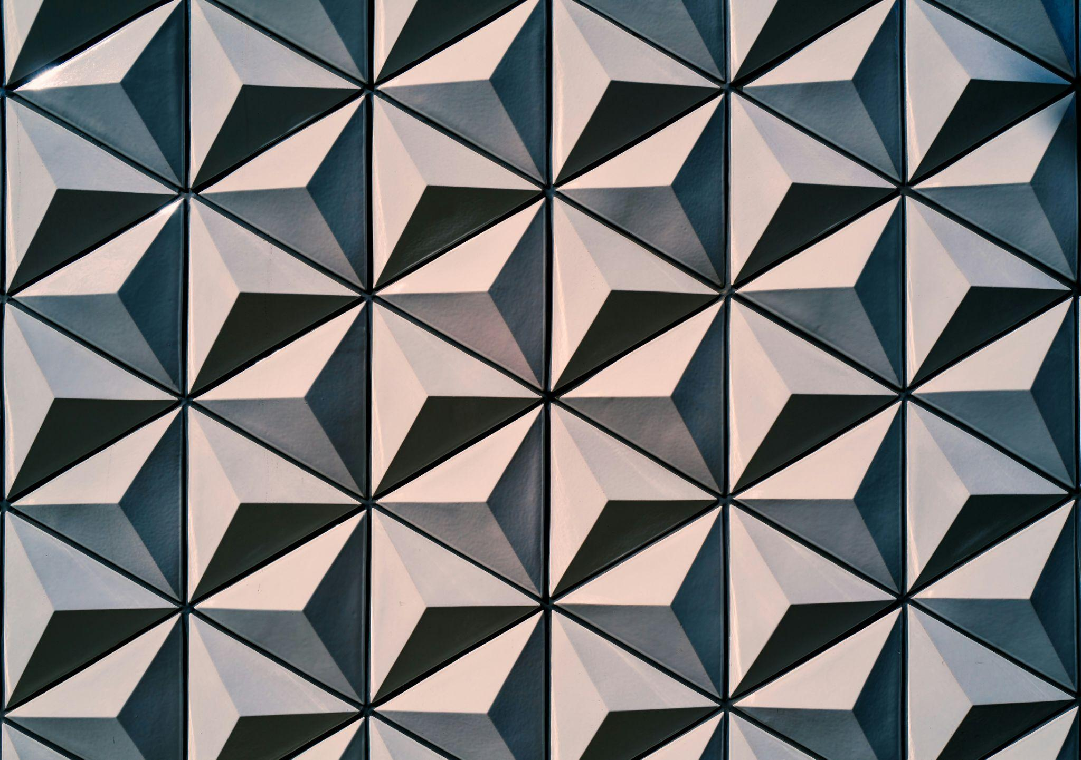

This image was obtained from unsplash.com and created by the blowup. This image is free for personal and commercial use with or without attribution. It is used as a texture for the banner on the Jun Street-Wear Apparel Website.

Color Palette

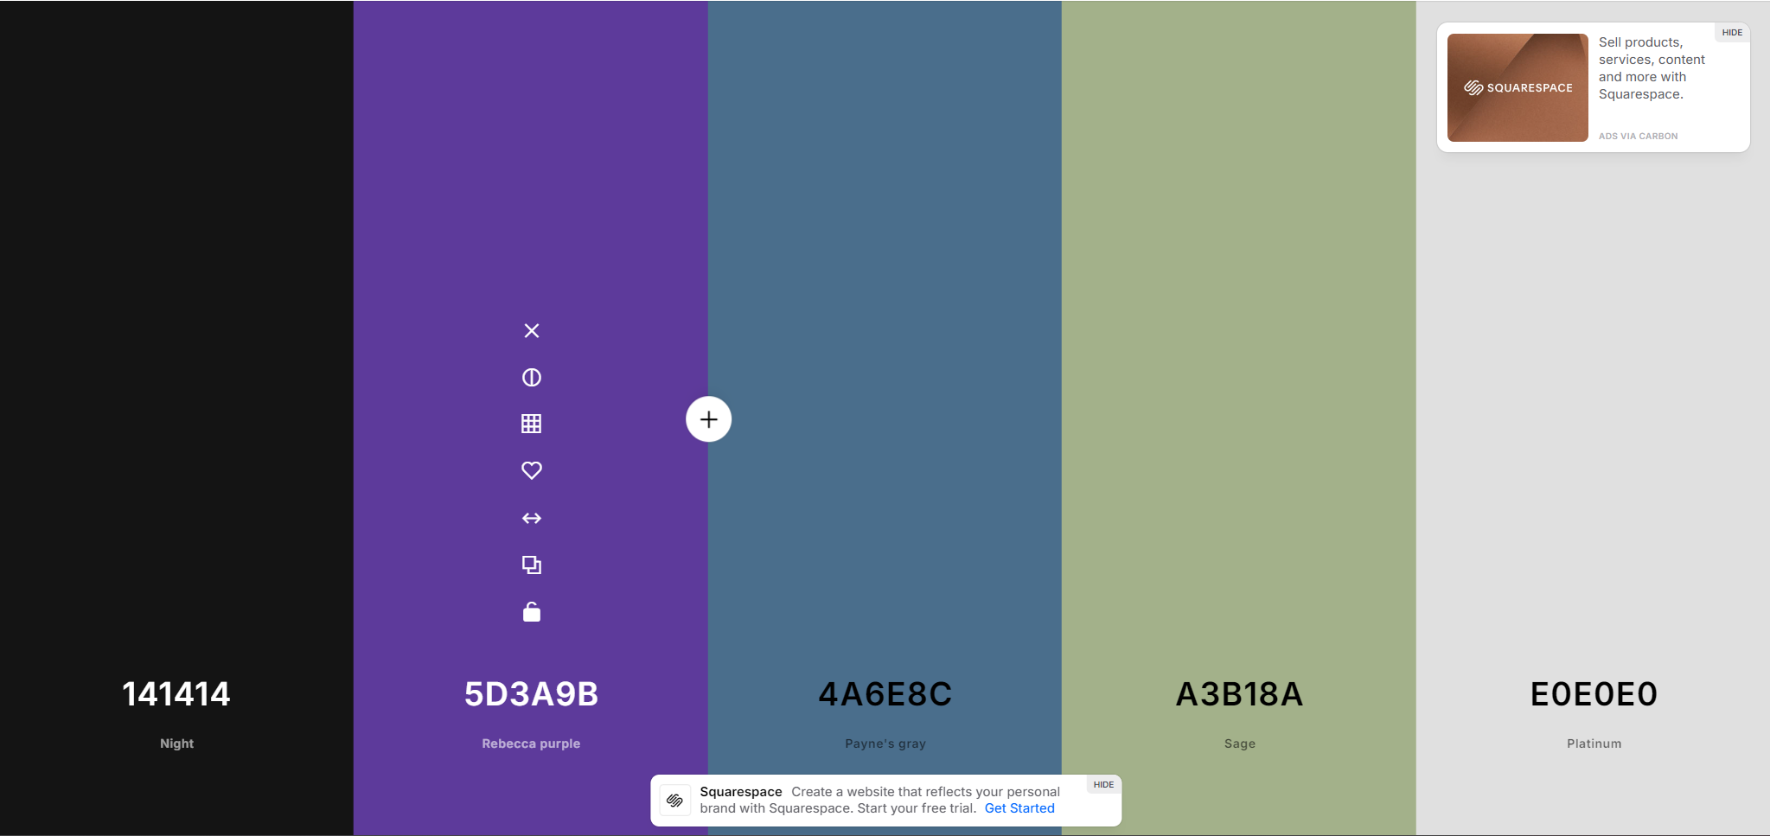

Backgrounds: The night black color is used for main backgrounds to create that sleek, modern feel. It also serves as a great base for the rest of the colors.

Accents: Sage, Payne’s Gray, and Rebecca Purple are used for accents. Their purpose is to add more depth to the color palette while keeping the feeling the brand aims to achieve.

Typography: Platinum is used for typography as it contrasts well with the main background color (night black) and keeps a subtle feeling by being a platinum instead of a complete white, blending the elements together while still keeping clarity and readability.

This color palette was generated using https:/coolors.org. The colors are a mixture of mysterious and subtle colors to appeal to the Street-Wear audience as well as taking inspiration from the brands designs of clothing.

# Banner

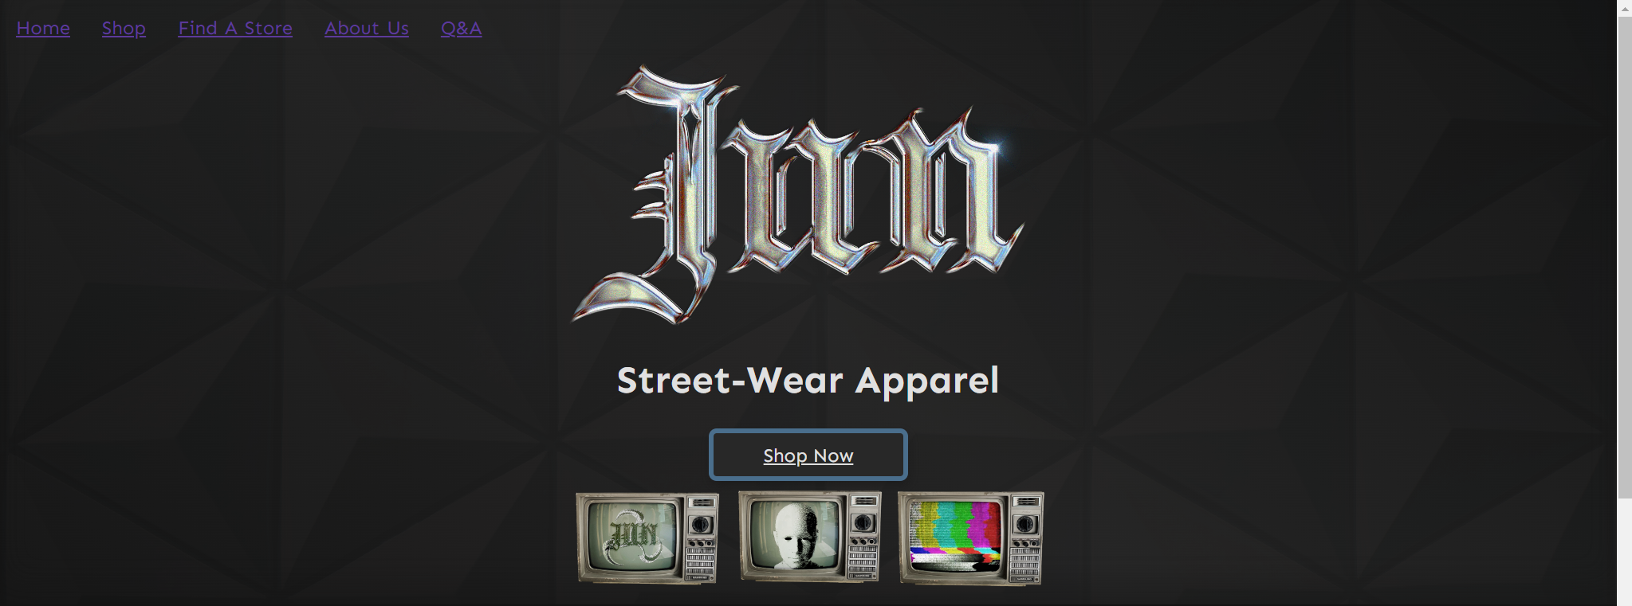

# Mobile Layout

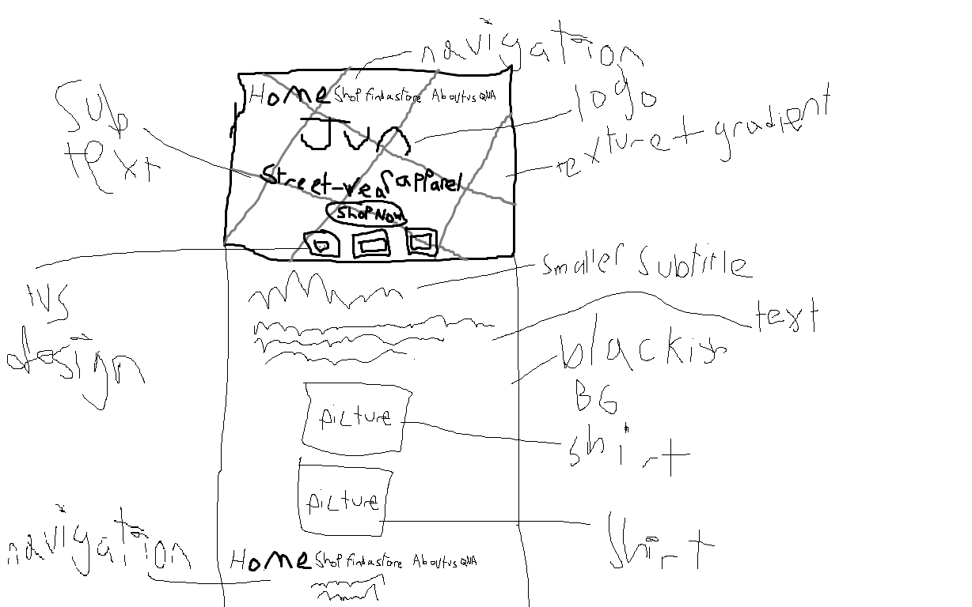

# Desktop Layout

